**FEDERAL JUDICIAL ACADEMY**

**ISLAMABAD  
\*\*\***

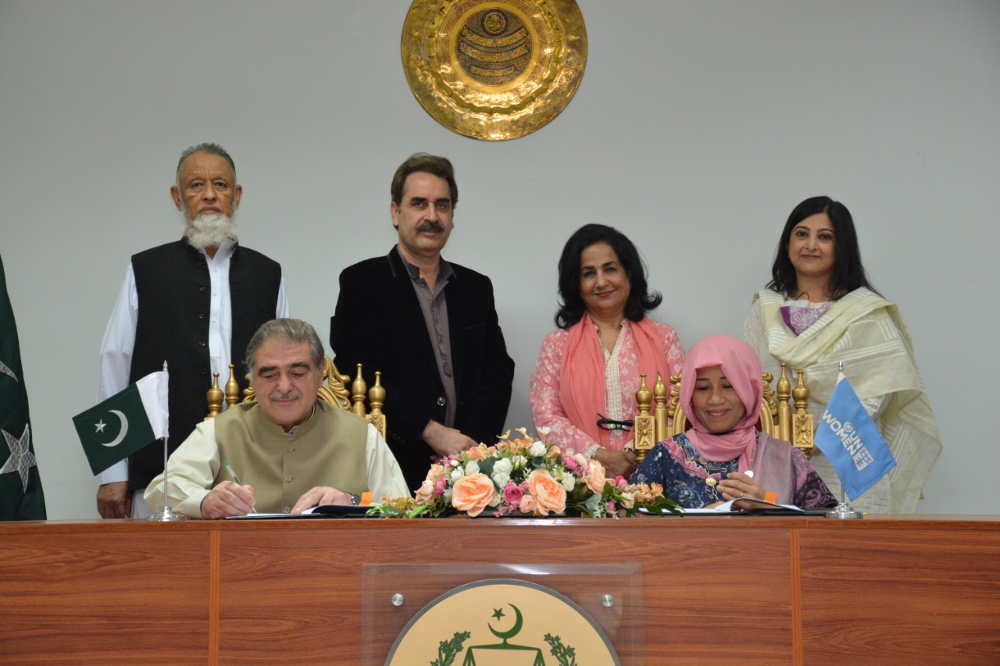

UN Women Flag of Pakistan and the Federal Judicial Academy signed an MoU today to enhance coordination on issues related to women empowerment and women's access to justice through building capacity of justice sector stakeholders and strengthening existing networks & coordination forums.